COUNT –AVTI

REPORT OF THE AVTI BOYS’ DORMITORY DEDICATION, 7, NOV 2012

30thNOV 2012

The program as planned started around 10.30am. The CYPRESSA FOUNDATION GUESTS were welcomed to the place of opening with the children drill.

All the Students and the Staff of TVET, School and Head Office attended the inauguration.

Rev. Dexter TJ Gollapalli, Director, COUNT chaired the dedication program.

In his address Mr. Peter, spoke on the central character from the bible, JONATHAN which the boy’s dormitory is named after. He stressed about Jonathan’s friendship with David and the bond they shared together.

He reminded us of the days when he and the volunteers labored in the hot sun in construction work. Even though they are not used to the hot conditions of India they worked here out of love for God. He said that they want to help the students to have good accommodation place so the foundation came forward to provide it. He also said of their volunteers who are jealous of him because they could not come for the opening. Once again he stressed that the Love of JESUS made them to come and do good for others.

The Visiting Guests team rendered two English hymnals with Martin on keys.

The main dormitory tablet was unveiled by Mrs. Cora Peter and the Jonathan plaque by Mrs. Martin. Bishop dedicated the building for the glory of God and for the benefit of the students; he blessed the building.

“We the staff and the students of AVTI like to thank all the donors and the NL TEAM Leader, Peter Sir and his group, who visited our campus initially and labored hard under the Sun in the construction of the building. We miss those days and cherish the moments we all had in the work of the Lord .we once again say THANK YOU all at Cypressa, NL for providing us a new facility”.

- Staff AVTI-COUNT

Thank you

-AVTI-COUNT

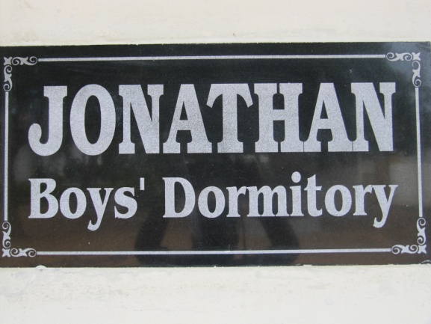 | 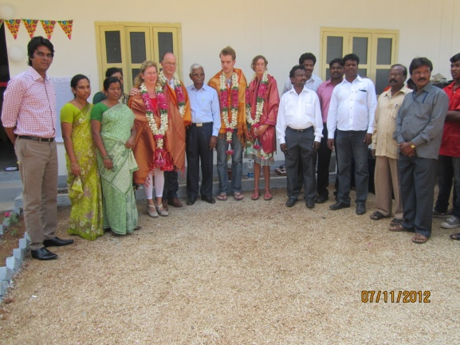
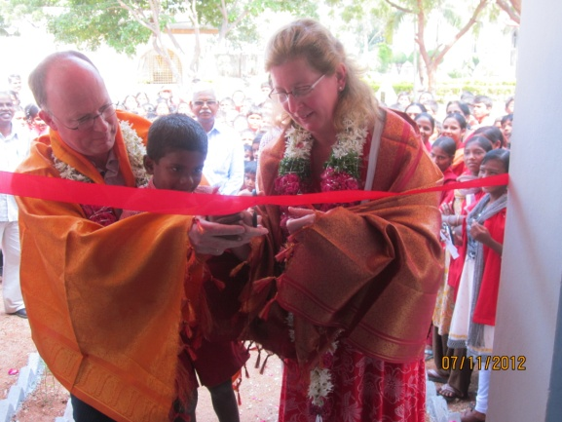 | 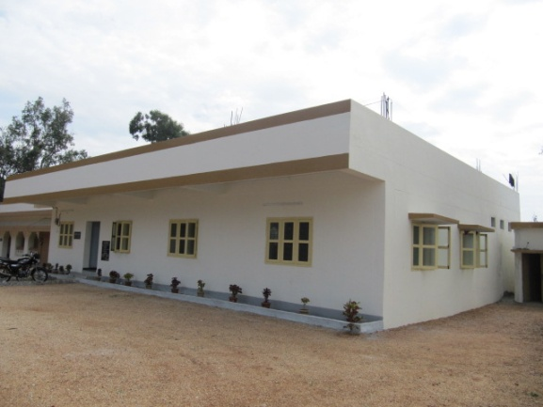

CHRISTIAN OUTREACH UPLIFTING NEW TRIBES
REPORT on Roof Top Solar PV System
At Agape Center, Hyderabad
With the financial grant from PETER EENENNAAM, NL

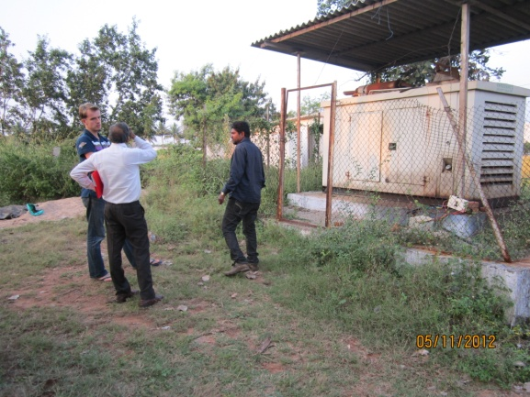 | 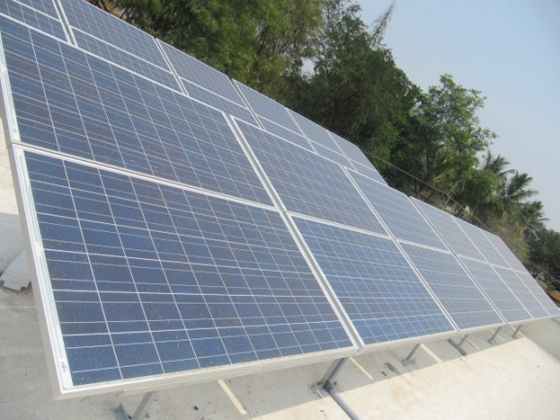

We at COUNT thank the Lord for giving and raising likeminded partners and donors in building the lives and working towards the extension of His kingdom.

In the initial years of Peter Eenennaam’s visit to the COUNT Campus, He wanted to invest in a project that can have manifold benefits for the society. After studying, the needs and weighing various options decided to prioritize the power bills issue. We mutually agreed to focus on bringing down the recurring monthly electricity bills problem.

The organization has been spending lot of money on the power bills every month for the different departments in the campus. Each building in the campus consumes energy, which runs into thousands of rupees every month. Every 2-3 years there is hike by the department on the electricity consumers that is becoming an additional burden for the organization to pay.

To resolve this issue Brother Peter consented to fund the 10 kw off grid Roof Top Solar PV system at Head Office, COUNT on pilot basis. Accordingly the consultations initiated from the year 2012, the experts from the Netherlands visited Agape Center, had consultations with the vendors on the capacity, price and other modalities with the local vendors.

Those were the days the government of India is pushing for solar energy but in our area of operations, there were very few companies in the solar energy. After receiving the best quotation NANO BRIGHT SOLAR TECHNOLOGIES firm was awarded the contract for the following works

Scope of work-
Execution of the 10kw RTS P System on the terrace of the Head Office Building at COUNT Campus
1. Design of Off –Grid solar PV System
2. Supply of Components, civil works
3. Installation and commissioning Of Solar PV System
4. Training and guidance on usage of the system
5. Annual Maintenance for 1 year

After the MOU with the vendor in the early 2013, the work progressed rapidly and started functioning from late summer.

Meanwhile we applied for the new net metering connection with the state Local electricity operation circle office of TSPDCL(earlier APPDCPL) as they are the sole state government implementing department for availing the NET METERING. Many in the department circles were ignorant of the new solar policy unveiled by the central/ state governments. We had to pay many visits to the various offices for moving of the file.

Finally we were approved of the NET METERING Box and the connection from the TSPDCL with our HO office consumer number after numerous visits to the department heads at various stages to move the file.

From the time of connecting to the grid, The HO bills have reduced drastically. Currently we are receiving the mandatory customer charges bill. The 10Kw RTS power system is functioning normally and without any major or recurring monthly expenses. There are also no maintenance expenses incurred for the last few years.

The HO office electricity bill is almost zero.
After seeing the success and the savings the organization can make,
The new provision is a boon to the children and great relief to the COUNT from the recurring monthly electricity bills.

Once we used to spend Rs 50,000- Rs 1, 00000 hefty electricity bills per month but it has drastically come down.

There is a need to bring down the electricity bills considerably by going solar for the other buildings such as bore wells, agriculture, dairy units, boys hostels conference hall, church.

The children, the staff and the management thank all the donors for their substantial contributions. We urge the Lord to bless the donors abundantly for their benevolence and prayers.

COUNT, India
CHRISTIAN OUTREACH UPLIFTING NEW TRIBES

A REPORT OF THE GOATS DISBURSEMENT

FOR THE ANDHRA-ODISHA REGION
WITH THE KIND SUPPORT OF - PETER -CYPRESSA, NL

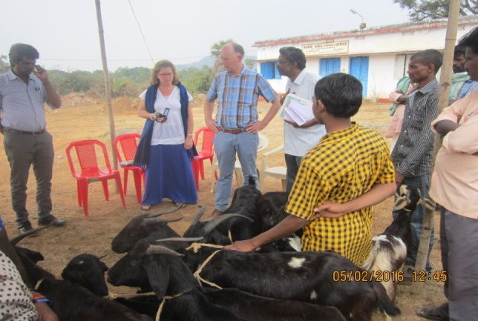 | 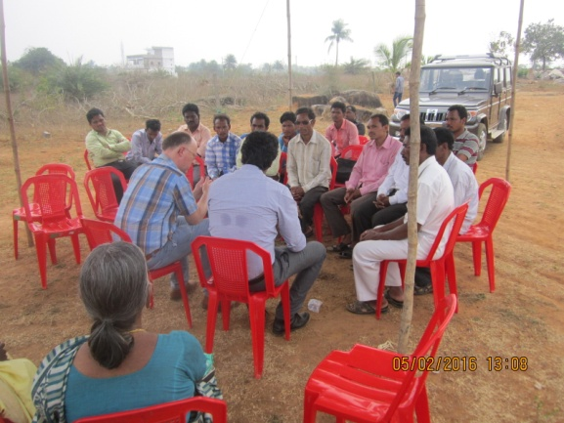
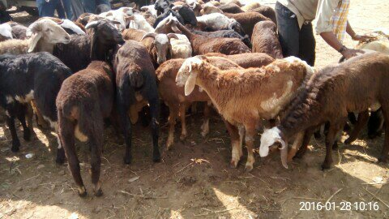 | 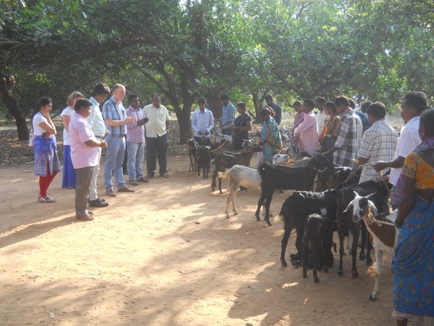

LOCAL FIELD LEADERS AND THEIR RESPECTIVE AREAS

-JOY PRASAD, REGIONAL SUPERINTENDENT, AP /ODISHA
-SUDARSHAN, H.P, PALASA
-YESUPADAM-COORDINATOR, SAVARA FIELD
-JAGGA RAO –SUPERINTENDENT, SEETHAMPETA
-KARTHIK GOMANGO, SUPERINDETENDENT/H.P, ODISHA
-NIMMA PAUL- FIELD LEADER, KURUPAM

With our local field and the HO staff, arranged the distribution to the beneficiaries in different phases. N.Paul the field leader along with Yesupadam arranged for the goats from the shepherds from various markets

Bro Peter and Mrs Peter too visited some places and distributed the goats to the beneficiaries in the tribal villages. COUNT, Director and Bro Peter had meetings with the local field staff and the beneficiaries. The beneficiaries have been waiting for a help such as this and are very thankful. After duly collecting the necessary documents such as ration cards, Aadhaar card and agreement letters. The distribution took place.
.
The beneficiaries THANKED, CYPRESSA for providing them with the help.
Each family received a pair of goats.

ANTONIA VOCATIONAL TRAINING INSTITUTE-COUNT
2017-18 report
ALC –RAMPACHODAVARAM, KONDAREDDY FIELD
Report of SEWING MACHINES for trainees at RAMPACHODAVARM center
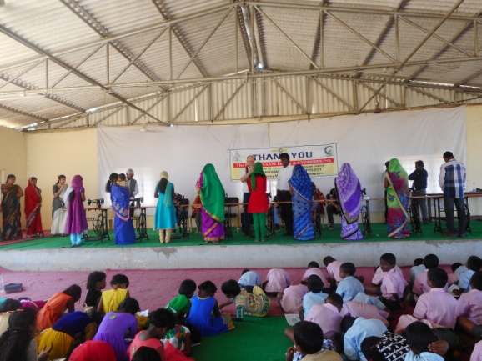 | 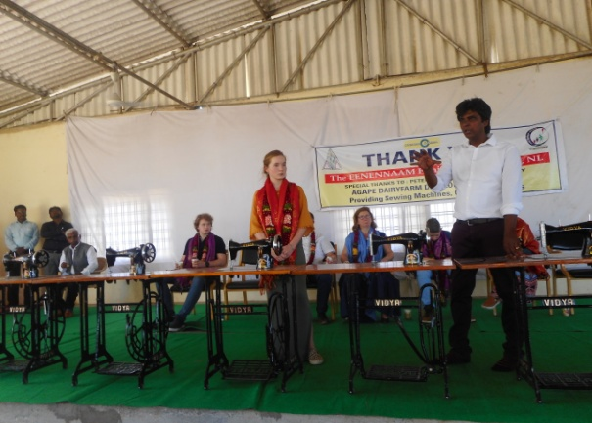
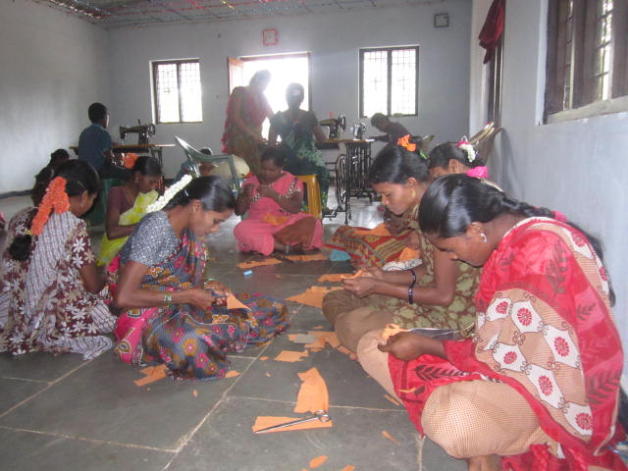 | 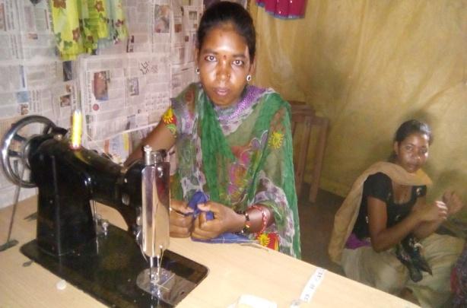

Tailoring program at the Lankapakala and surrounding villages.

The youngsters and women trainees of the Agape skill training program of AVTI –COUNT who are trained in the tailoring expressed the need for owning the sewing Machines so as to have grip on the skill and earn some money to support the family. Nevertheless, due to financial constraints they are unable to make purchases. A few of them, whose families can afford bought new sewing machines, the less fortunate ones are left with no source of buying the Machine. They are requesting and praying for the Lord to open a way.
Hearing of the stories and the need for sewing machine of COUNT program,

Bro Peter’s family was kind enough to sponsor for the Sewing machines.

The beneficiaries and the COUNT appreciate and Thank the Lord for the remarkable motivation and zeal of Esther Eennanam the young daughter of Mrs Cora and Peter Eenennaam for saving and working hard to collect the needed money to buy the required sewing machines. The deed by her inspired many of us at COUNT.

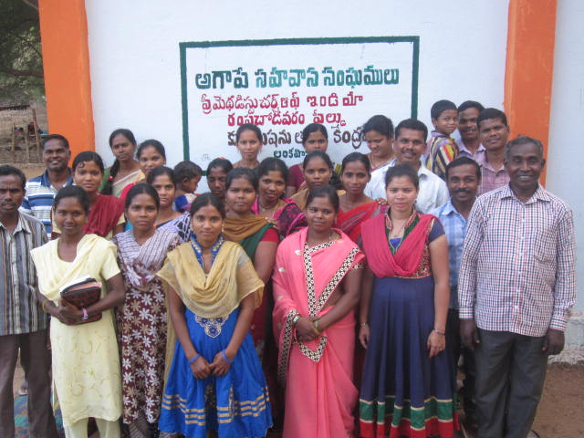
We thank COUNT and Bro Peter’s family especially Esther for her dedication and concern for people like us who are miles away. You chose to work hard to raise the sum required to give our area center trainees with new sewing machines. The gift will help the women of our area to stand on their own and earn extra income for the family .You are an inspiration for all of us at Rampachodavarm field.

– Rev.Ch. Yohan Reddy, Rampachodavaram Area Superintendent

Beneficiaries list:

S.No | name |  | D/W of | village
1 | P.RAMULAMMA | W/O | RAMA KRISHNA | LANKAPAKALA | ALC
2 | M.VIJAYA VANI | W/O | VEERA REDDY | YARLAMAMIDI | ALC
3 | S.NAGAMANI | W/O | PANDU | PEERUKONDA | ALC
4 | S.SALOMI | W/O | SANTOSH REDDY | THUNNOR | ALC
5 | K.PARAMESHWARI | W/O | CHANDRA REDDY | PEERUKONDA | ALC
6 | DEEVENA | D/O |  | EETHAPALLY | AVTI
7 | S.MARY | D/O | S.AHARONREDDY | KOYYALAGUDEM | AVTI
8 | S.SOWJANYA RANI | D/O | RAJAREDDY | PEERUKONDA | AVTI
9 | K.SURYAKANTHAM | D/O |  | BOLAGONDA | AVTI
10 | SARA | W/O | GANESH | ETURNAGARAM | AVTI

CHRISTIAN OUTREACH UPLIFTING NEW TRIBES
Report of the Agape Dairy
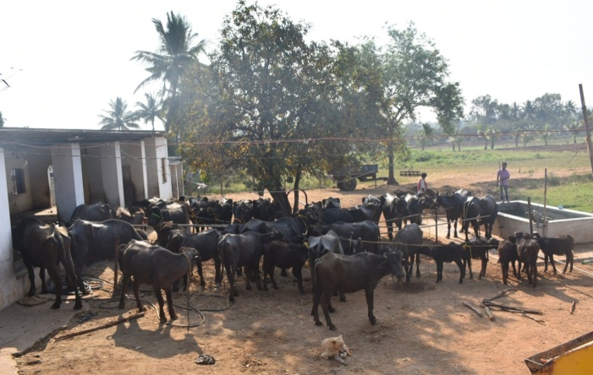 | 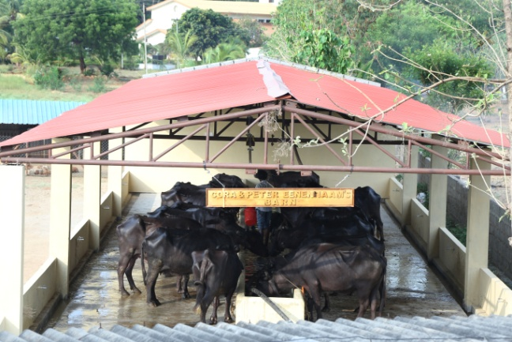
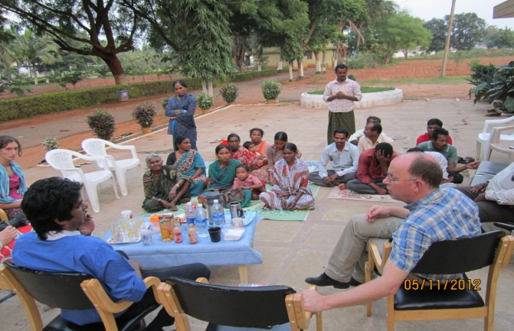 | 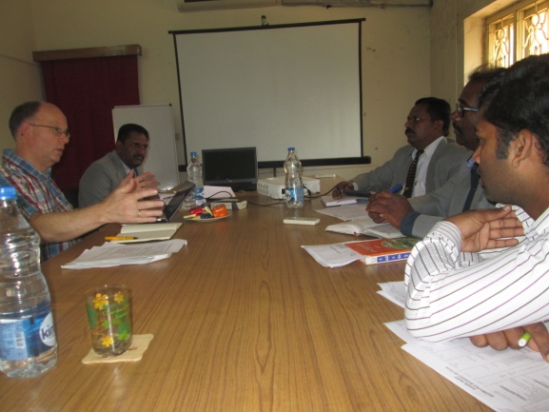

AGAPE DAIRY: Our water buffaloes are healthy and are taken care by the dairy staff. The dairy is monitored under the supervision of the Self-help project supervisor. A veterinary doctor visits the farm twice a month and also attends in times of emergencies.

SIZE- Currently we have 46 water buffaloes. 22 adult female buffaloes and 24 calves (5 male, and 19 female between 2 months to 2 years).
We sell the male calves and retain the female calves.

BARN:
Mrs. Cora and Mr. Peter Eenanaam from the Netherlands supported us to construct the Agape barn in the year 2018. The new barn (with the attached cottages) is serving the purpose for which it has been intended. The new shed with better plan and good facilities accommodates about 30 buffaloes that needed shelter. It is being maintained properly.
The water buffaloes are segregated into milk yielding buffaloes in one barn and the remaining in the other. We are happy that there are two cottages attached which provide accommodation to the dairy staff and also they can be close to the place of work. The old barn rooms are utilized for storing the purchased concentrate feed- cotton cake, rice bran, husk, wheat flour and maize flour.

GRASS/FEED:
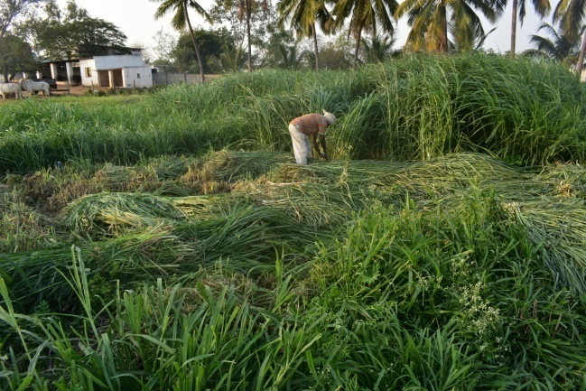
We are cultivating two different varieties of grass in the campus, SSG and HYBRID Napier type. We augmented the homegrown green grass cultivation from the earlier two acres to 4 acres. There is a new variety of grass buds in the market, which is becoming popular; it grows between 12-15 feet height, we are contemplating of cultivating the new model in the coming days. Presently we are experiencing severe heat as the summer has set in very early. There is depletion of water levels as the ground water table is going down due to urbanization and developmental activities around us.

Grass is sufficient in winter and rainy seasons but there is scarcity in the summer months and it has become necessary to procure hay from the market at a high price, due to its huge demand.

MILK:
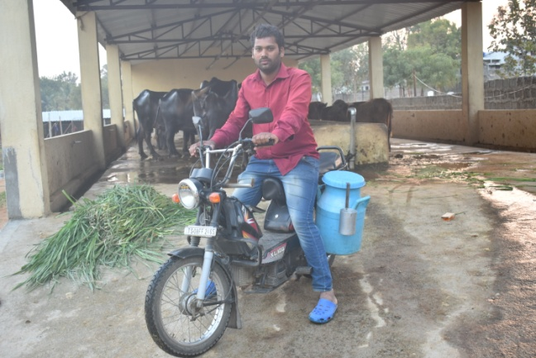
On an average 50-60 liters of milk is produced taking into consideration the milking and dry days. Each liter of milk is fetching Rs 55-60 .The milk supplied is pure and unadulterated which is very hard to find in the open market however, the rates are not growing as per the quality. The maximum amount is Rs 60 per liter, there has been no rise in the prices by the milk federation for a long time. The milk is being supplied to the hostel, staff and the outsiders.

BY PRODUCT- Dung:
40 tractor load of manure is produced during this year. The hay from paddy cultivation is utilized by the dairy and vice versa the dung generated from the dairy unit is utilized for use in the fodder and agriculture cultivation activity.

Pure Ghee: Ghee is produced, it is supplied to the children’s kitchen in food preparations and the rest is sold to staff and in the open market at Rs 600 per kg

We take this opportunity to thank the Lord and our donors who have generously contributed in the agape dairy development. Presently the buffaloes are being accommodated in the barns. For the future expansion, there is need for extension of the sheds and purchase of more milk yielding buffaloes. There is also the need to bring down the costs such as electricity. Electricity is required for the bore wells, motor, and cutting operations, fans, lightings.

-AGAPE DAIRY ,COUNT

Christian Outreach Uplifting New Tribes
COVID - 19
RELIEF REPORT
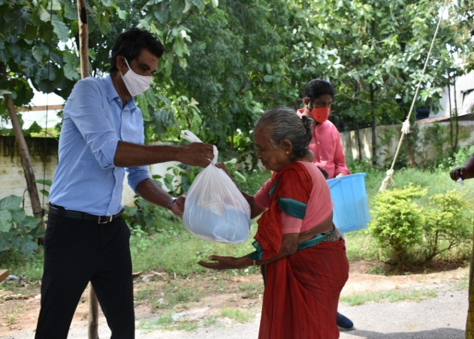 | 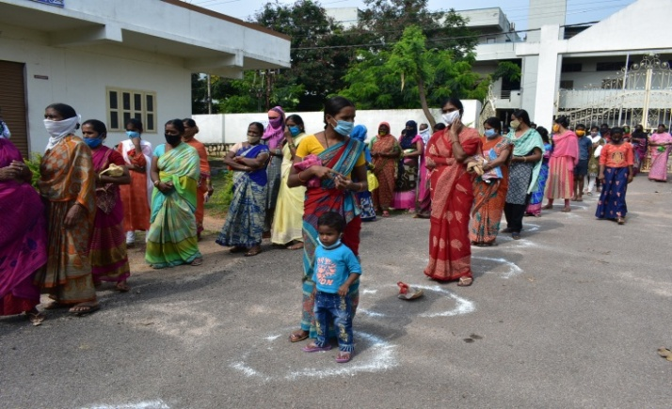

We have all been affected by covid pandemic in some way or the other. The virus continues to be unrelenting with many new cases of infections. The lockdown phase is slowly lifted but many have lost their jobs, income sources and secure living. The people are now advised to live with the Virus taking precautions and following the safety measures. We are extremely grateful to our Lord Jesus for His guidance and our donors for their generosity in helping the most needy and migrant workers during this pandemic situation.
We at COUNT have also been severely affected by covid as we lost 4 senior staff of COUNT who were very dear to us. The first child of COUNT, Rev Elisha, Mr. Samuel our senior accountant, Mr. Jayshekar, Pastor and school teacher at St. John’s school, and Mr Sudhakar, our electrician. Please remember the families who miss their loved ones in your prayers.

Section A: Basic Information:
Project title | COVID -19 -RELIEF
Donor org | Peter –CYPRESSA FOUNDATION ,NL
Program | Disaster Relief
Project-Location | Neighbourhood colonies around agape center, Hyderabad ,TS,INDIA
The name of the Implementing  Partner | COUNT ,INDIA
Contact Person | DEXTER T. J GOLLAPALLI
Designation | Executive Director
Address- Office | Agape center,Chengicherla, Medchal-malkajgiri district,  Hyderabad ,Telangana ,INDIA
E-mail | dextergollapalli@gmail.com

Section B- Purpose:
COVID -19 pandemic has adversely affected the whole world and India with its 1 billion people has been in severe crises. The immediate measure of announcing nation-wide lockdowns has adversely affected the salaried, middle class, daily wagers, poor Dalit and tribal families. All services except essentials were shut down for more than 2 months.

The colonies around the agape centre are the migrants coming from different states with large unskilled labor class eking out their livelihood by working in MSM factories nearby. Many companies scaled down their productions due to the low economic activity. This paved the way for job loss to all sections of the society. This affected the working class resulting in unemployment, working in new environment as helpers with fewer wage.

Section C- Project Achievement:

COUNT has been able to fulfill the Lord’s mandate in times of need with relief materials along with the spiritual nourishment.
The relief work was done with the active participation from the respective local area leaders’ .the village elders and political representatives in the free distribution.
The local communities were happy for the community service extended to the needy beneficiaries.

BENEFICIARIES TABLE:
S.No | Communities | No.of families | Beneficiary Item | Area
1. | Weaker section colonies | 500 | Dry Ration kits | Neighbourhood colony,AC,hyderabadTelangana,

Description | Activities done
Purchase of Rations | Purchased Rations
Sorting of ration kits | Purchased groceries have been packed into kits and provided to the poor Families of the colonies in the Hyderabad, Telangana
The staff/local coordinators , volunteers in Distribution | Survey of the beneficiaries was done. Quotations, distribution points, areas, list of beneficiaries, items procurements and other required data have been collected. The requirements have been examined and validatedby the concerned officials

Section D -Stories of Gratitude:
P BURUNDA

I, the believer of Agape like to say few words. While we were struggling without food during the lockdown, your provision of essential items has enabled us to eat food.

We are praying for you and please pray for us.
Provision of essential items such as Rice, lentils, oils etc has made our home kitchen to run. We will never forget the help extended to us.
Our communities are living in the dangerous virus period so please pray for us

We thank the Lord for all the partners in helping the beneficiaries in the corona situation.

Christian Outreach Uplifting New Tribes

COUNT-AGAPE AGRI PROJECTS
FARM TRACTOR & EQUIPMENT REPORT
SELF-SUPPORT PROGRAM

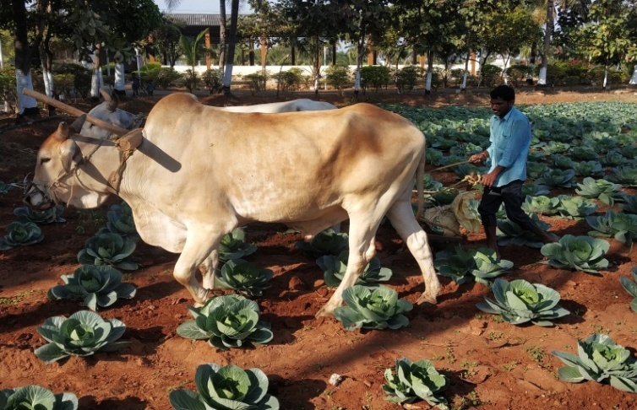 | 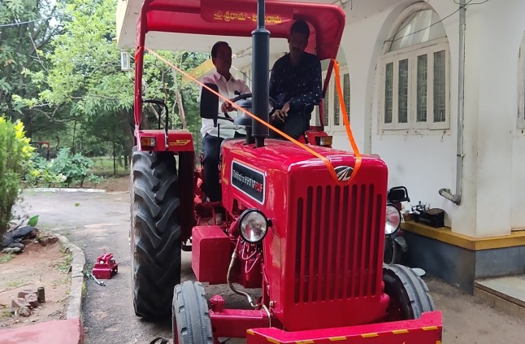
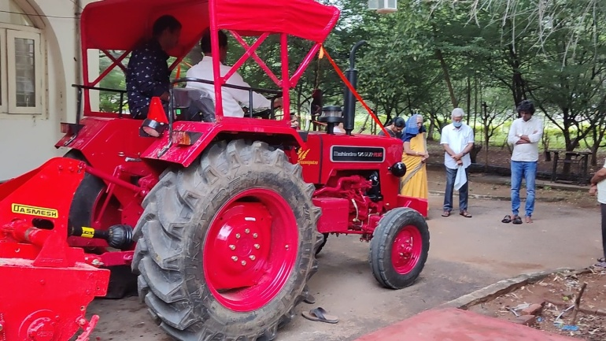

Project Overview– Need for the Tractor:

COUNT has been striving to raise and look for opportunities in developing the local income generation programs since its inception. The self-help Projects are also partakers in the realization of Organization’s goals, contributing to the final cause in different forms- Agriculture, dairy, sheep , colleges and schools. These are not only taking share in the human development but also able to provide and create employment opportunities for the marginalized families.

Agriculture activity is one of the self-support programs; through it we are able to meet the vegetables, Tamarind , flowers, fruits, pickles from mango ,lime food requirements of the campus hostel students ,staff and outsiders.

We could able to do the agriculture activity at Agriculture and Dairy units of Agape Centers with the help of machines -. It helps us to do hard job easily and efficiently. Six years back, we went and bought old used Tractor with more HP through our agriculture savings to do the work to avoid the heavy expenses of purchasing a new tractor. It gave good service until few months back. Being an old tractor, it was not wise to invest in recurring expenses repeatedly. Off late, we could no more utilize the tractors, they served their purpose.

Benefits and Changes after acquiring New Tractor & Implements
The tractor has arrived on time for the agriculture activity in the monsoon paddy cultivation. We pressed the new one into the service immediately after acquiring it, we could overcome the labor shortage, do the cultivation work quickly in due season.

- New tractors has technologically advanced features
- The machines are more farmers friendly
- They are Fuel-efficient
- The New tractors has many new agriculture implements as attachments than our earlier model
- It has power steering , the old one was manual and was hard now it is easy and has less fatigue
- With the use of the new one we are able to save on wages
- We used to incur more expenses on spares and servicing on old tractor.
- Frequent hiring of tractor from outside is avoided.

We sincerely THANK the donors for helping us in meeting our agriculture requirement this act will strengthen the vision of the COUNT for the coming generations in reaching with the good news of the Lord and sharing HIS Love.

With the arrival of new tractor and implements, we could able to save the money. Earlier we used to spend the money on laborers and the tractor hiring expenses. We, the team of workforce at Agape thank the lord for the new agriculture needs and may the Lord bless the donors richly –

AGAPE Agri & Dairy, COUNT

